1

INTELLIGENT ADMISSIONS: THE FUTURE OF UNIVERSITY DECISION MAKING WITH MACHINE LEARNING

TEAM MEMBERS NAME: V.CHITHRA
V.TAMIZH SELVI
V.HARISH
I.KATHIRAVAN
CLASS
III-BCA (COMPUTER APPLICATION

TABLE OF INDIX

S.NO | DESCRIPTION | PAGE NO
1 | INTRODUCTION
2 | PROBLEM SOLVING & DESIGN THINKING
3 | RESULT
4 | ADVANTAGES AND DISADVANTAGES
5 | APPLICATION
6 | CONCLUSION
7 | FUTURE SCOPE
8 | APPENDIX

1. INRODUCTION
1.1 OVERVIEW
UNIVERSITY ADMISSION PREDICION
- University admission is the process by which students are selected to attend a college or university. The process typically involves several steps, including submitting an application, taking entrance exams, and participating in interviews or other evaluations.
- Students are often worried about their chances of admission in University. the university admission process for students can be demanding, but by being well-informed, prepared, and organized, students can increase their chances of being admitted to the university of their choice.
- The aim of this project is to help students in short listing universities with their profiles. Machine learning algorithms are then used to train a model on this data, which can be used to predict the chances of future applicants being admitted.
- With this project, students can make more informed decisions about which universities to apply to, and universities can make more efficient use of their resources by focusing on the most promising applicants.

1.2 PURPOSE

- The business requirements for a machine learning model to predict chances of student admission in the university.
- A project aims to predict the chances of a student getting admitted to a particular university based on certain factors The business value of this project is that it will help students make more informed decisions about which universities to apply to, and help university counselors to better advise students on the universities they are most likely to be admitted to the university
- The University Chances of Admission project is a well-researched topic in the field of education and machine learning. Many studies have been conducted to predict university admission using different machine learning techniques
- The ability to accurately predict the chances of university admission can help students make more informed decisions about which universities to apply to, increasing their chances of being admitted and ultimately gaining access to higher education
- An increase in the number of successful admissions can lead to an increase in revenue for universities, as well as for the company providing the prediction service.

2. PRBLEM DEFINITION & DESIGN THINKING
2.1 EMPATHY MAP
In the ideation phase we have empathized as university admission prediction with machine learning and we have acquired the details which are represented in the Empathy map given below
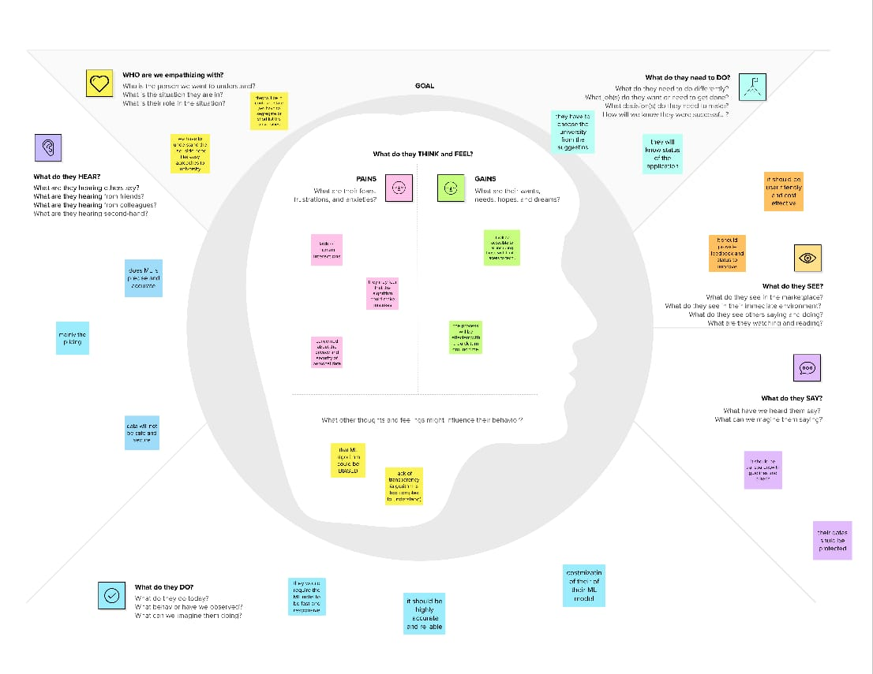

2.2 IDEATION BRAINSTORMING MAP
STEP 1: Team Gathering, Collaboration and select the problem

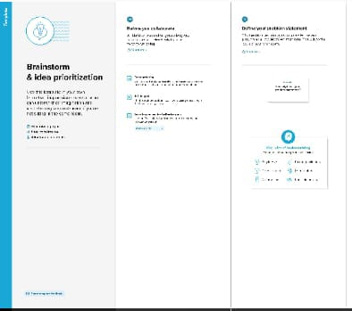

STEP 2: Brainstorm, Idea Listing and Grouping

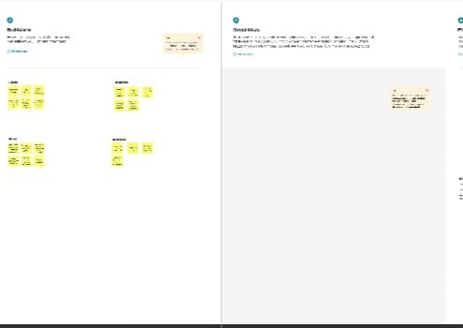

STEP 3: Idea Prioritization

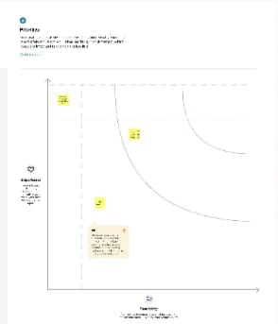

3. Results
Handling missing data
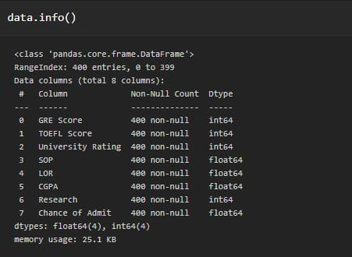

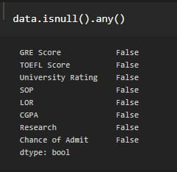

Exploratory data analysis
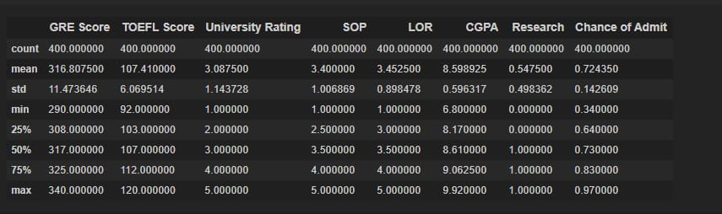

Visual analysis
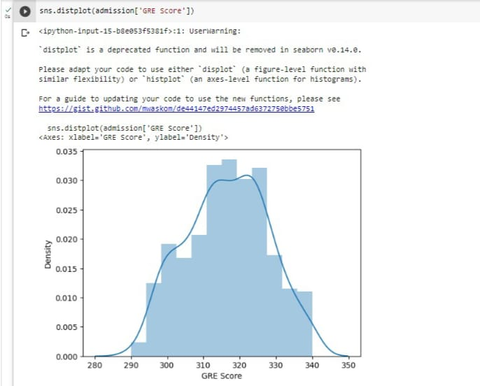
Bivariate analysis
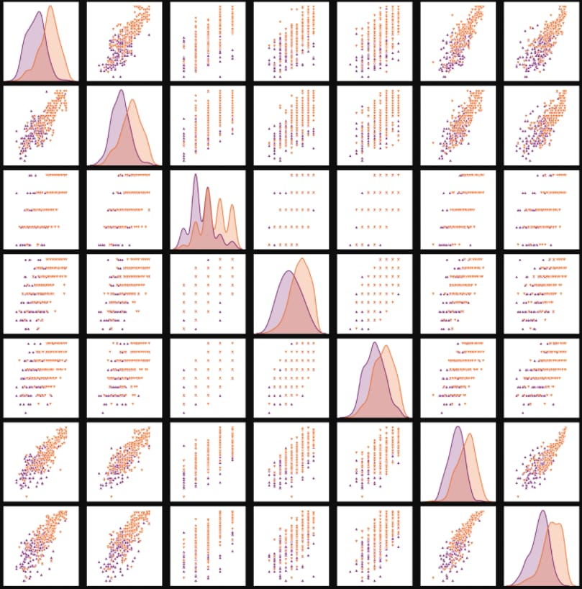

Model building
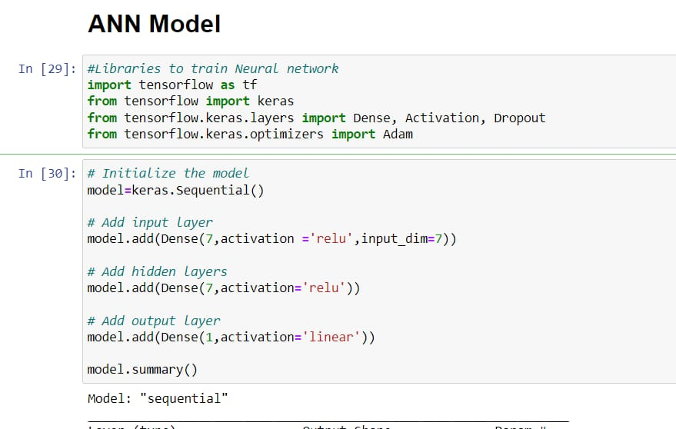
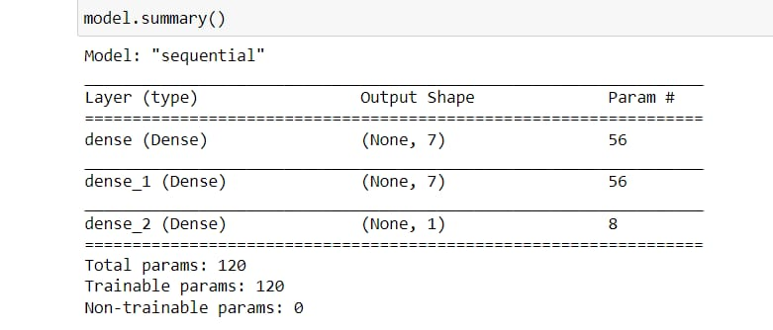

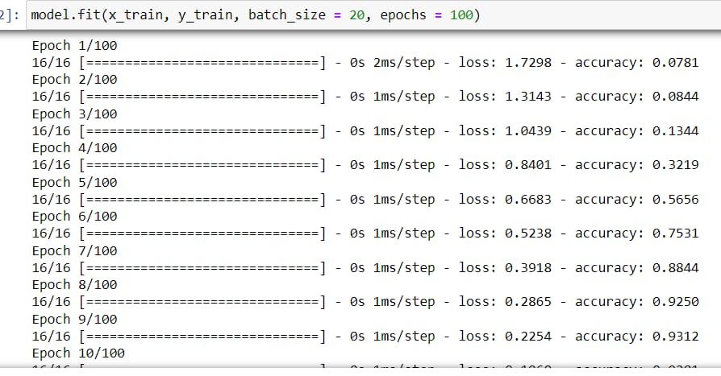

Testing the model
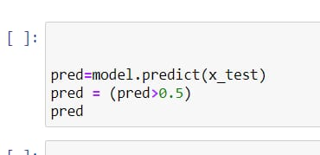
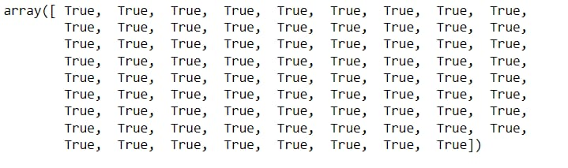

Performance testing & Hyperparameter Tuning
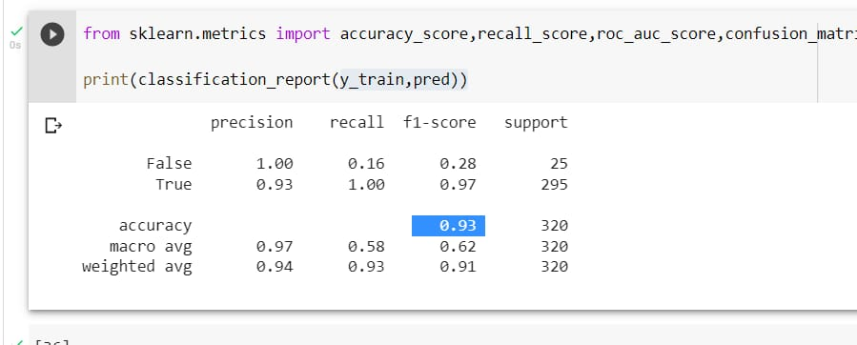
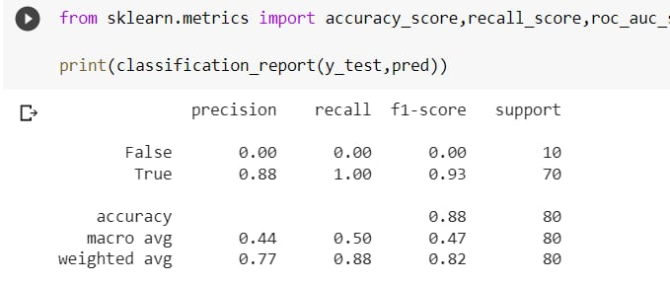

ADVANTAGES & DISADVANTAGES
Advantages
It helps student for making decision for choosing a right college.
Here the chance of occurrence of error is less when compared with the existing system.
It is fast, efficient and reliable.
Avoids data redundancy and inconsistency.
Very user-friendly.
Easy accessibility of data.

Disadvantages
Required active internet connection.
System will provide inaccurate results if data entered incorrectly.

APPLICATION
In the system proposed, a person can enter their scores in the respective fields provided. The system then processes the data entered and produces an output of the list of colleges that a person could get into, with their scores. This is relatively quick and helps conserve time and money. In order to achieve this we have proposed a novel method utilising Machine Learning algorithms. To maximize the accuracy of our model, we have taken into consideration not one; but several machine learning algorithms. These algorithms include Neural Networks, Linear Regression, Decision Tree and Random Forest. More about these algorithms will be covered in the Algorithms section of this paper. These Algorithms are then compared and the algorithm which has the best key performance indicators will be used to develop the Prediction System. We also look forward to incorporate clustering of universities based on a profile and then classifying them as less likely, highly likely acceptance etc

CONCLUSION

Every year millions of students apply to universities to begin
their educational life. Most of them don’t have proper
resources, prior knowledge and are not cautious, which in
turn creates a lot of problems as applying to the wrong
university/college, which further wastes their time, money
and energy. With the help of our project, we have tried to
help out such students who are finding difficulty in finding
the right university for them. It is very important that a
candidate should apply to colleges that he/she has a good
chance of getting into, instead of applying to colleges that
they may never get into. This will help in reduction of cost as
students will be applying to only those universities thatthey
are highly likely to get into.Our prepared models work to a
satisfactory level of accuracy and may be of great assistance
to such people. This is a project with good future scope,
especially for students of our age group who want to pursue
their higher education in their dream college

FUTURE SCOPE

The primary objective of this work is to make a Machine Learning model which could be utilized by understudies who need to seek after their Education.
Many AI algorithms were used for this examination.
Linear Regression model contrasted with different models gives the best outcome.
Understudies can utilize the model to survey their shots at getting induction into a specific University with a normal exactness of 82%.
An ultimate objective of examination will be cultivated effectively, as the framework permits understudies to save the parcel of
time and cash that they would spend on instructive guides and application charges for schools where they have less shots at getting affirmations.
In future this module of expectation can be incorporated with module of robotized handling framework and different models like neural organization.
Likewise, segregate investigation can be utilized independently or joined for upgrading dependability and precision forecast.
At long last, understudies can have an open-source AI model which will assist the understudies with knowing their opportunity of entrance
into a specific college with high exactness.

SOURCE CODE

import numpy as np # linear algebra
import pandas as pd # data processing, CSV file I/O (e.g. pd.read_csv)
import matplotlib.pyplot as plt
import seaborn as sns
import pickle
from google.colab import files
uploaded = files.upload()
from google.colab import files
uploaded = files.upload()
admission.head() # to see the top five records of the data sets
admission.shape # to see what is the shape of data_set our data set has 400 records and 9 fields
admission.columns #to see the name of the fields
admission.describe() # to see the mathematical values of the data sets i.e mean,standar_deviation ,minimum_value,maximum_value,counts etc.
admission.info() #to see the type of values in every fields i.e int ,float etc
admission.isnull().sum() # to see that if dataset has any null_values or not
# now preparing the input data_set and out_labels
X=admission.drop(['Serial No.','Chance of Admit '],axis=1) #input data_set
X.shape
y=admission['Chance of Admit '] #output labels
y.shape
admission.sample(5)
sns.distplot(admission['GRE Score'])
plt.figure(figsize=(10, 10))

sns.heatmap(admission.corr(), annot=True, linewidths=0.05, fmt= '.2f',cmap="magma")

plt.show()
sns.pairplot(data=admission,hue='Research',markers=['^','v'],palette='inferno')
plt.scatter(admission['University Rating'],admission['CGPA'],color='Red',s=100)
plt.title('CGPA vs University Rating')
plt.xlabel('University Rating')
plt.ylabel('CGPA')
plt.show()
category=admission.columns
color=['Red','Pink','Orange','Yellow','Purple','Green','Blue','Brown']
start=True
for i in np.arange(4):
fig=plt.figure(figsize=(14,8))
plt.subplot2grid((4,2),(i,0))
admission[category[2*i]].hist(color=color[2*i],bins=10)
plt.title(category[2*i])
plt.subplot2grid((4,2),(i,1))
admission[category[2*i+1]].hist(color=color[2*i+1],bins=10)
plt.title(category[2*i+1])
plt.subplots_adjust(hspace=0.7,wspace=0.2)
plt.show()
x= admission.drop(['Serial No.','Chance of Admit '],axis=1)

x
y= admission['Chance of Admit ']
y

from sklearn.preprocessing import MinMaxScaler
sc=MinMaxScaler()
x=sc.fit_transform(x)
#splittin the input data(x) and output labels(y) into train data and test data
from sklearn.model_selection import train_test_split
X_train,X_test,y_train,y_test=train_test_split(X,y,test_size=0.20) # test_size defins the volume of train data and test data here 0.2 means 20% of the data belongs to the test data
X_train.shape
X_test.shape
from sklearn.preprocessing import MinMaxScaler
scaler=MinMaxScaler()
X_train[X_train.columns] = scaler.fit_transform(X_train[X_train.columns])
X_test[X_test.columns] = scaler.transform(X_test[X_test.columns])
X_train.head()
from sklearn.ensemble import RandomForestRegressor
rgr=RandomForestRegressor()
rgr.fit(X_train,y_train)
rgr.score(X_test,y_test)
import xgboost as xgb
xg = xgb.XGBRegressor()
xg.fit(X_train,y_train)
xg.score(X_test,y_test)
y_predict=rgr.predict(X_test)
y_predict
from sklearn.metrics import mean_squared_error, r2_score,mean_absolute_error
import numpy as np

print('Mean Absolute Error:', mean_absolute_error(y_test, y_predict))
print('Mean Squared Error:', mean_squared_error(y_test, y_predict))
print('Root Mean Squared Error:', np.sqrt(mean_squared_error(y_test, y_predict)))
import tensorflow as tf
from tensorflow.python import keras
from keras import layers
from keras.layers import Activation,Dense,Dropout
classifier=keras.Sequential()
classifier.add(Dense(7, activation='relu', input_dim=7))
classifier.add(Dense (7, activation='relu'))
classifier.add(Dense(1, activation='linear'))
classifier.compile(optimizer='adam',loss='binary_crossentropy', metrics=['accuracy'])

model_history = classifier.fit(X_train, y_train, batch_size=100, validation_split=0.2, epochs=100)
classifier.summary()
from sklearn.metrics import accuracy_score,classification_report
train_predictions=classifier.predict(X_test)
print(train_predictions)
train_acc=classifier.evaluate(X_train, y_train, batch_size=128)
print(train_acc)
test_acc=classifier.evaluate(X_test,y_test,batch_size=128)
print(test_acc)
pred=classifier.predict(X_test)
pred=(pred>0.5)
pred
pickle.dump(RandomForestRegressor, open('hctk.pkl' ,'wb'))

